Java 21 Features

- Unnamed Classes & Instance Main (preview)
- String Templates (preview)
- Sequenced Collections
- Record Patterns
- Pattern Matching for Switch
- Virtual Threads

Unnamed Classes & Instance Main Methods

- Unnamed Classes
  - You don’t need to declare public class.
  - The compiler automatically wraps your code in a class.
- Instance Main Methods
  - You don’t need static void main(String[] args).
  - Instead, you just write void main() inside the unnamed class.
- Great for learning & quick scripts
  - Makes Java feel closer to scripting languages (like Python).
  - But it’s only for small programs (not for full production apps).
Example:
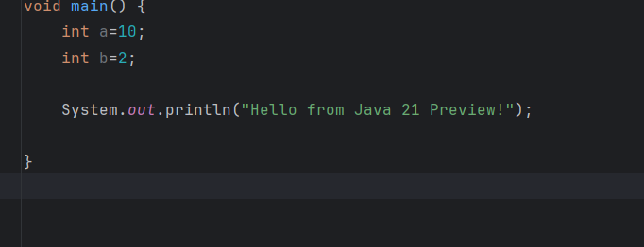

String Templates
String Templates are a new way to build strings in Java (preview feature).
Instead of writing long + concatenations or String.format, you can embed variables and expressions directly inside strings.
Syntax
Two important things:
- Template Processor → STR (built-in processor for plain strings).
- Template expression → Written inside ${ ... }.
Example:
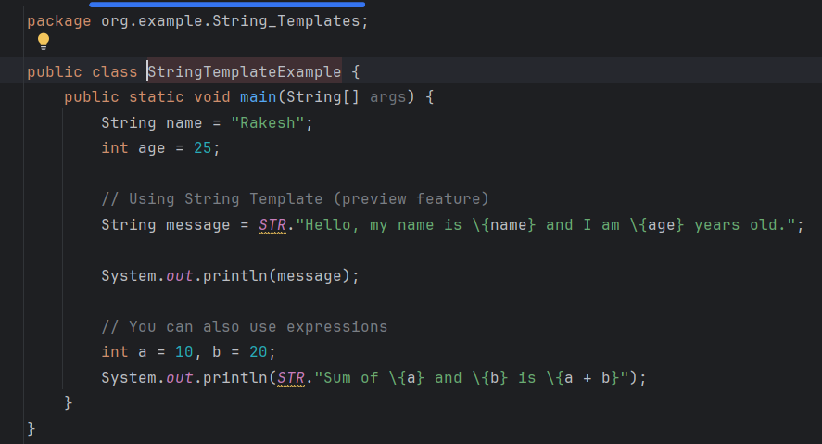Output:
Hello, my name is Rakesh and I am 24 years old.

2. Using FMT (Formatted Templates)
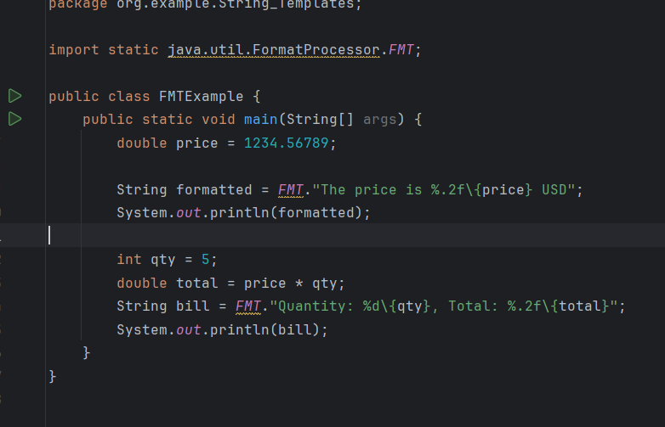Output:
The price is 1234.57 USD
Quantity: 5, Total: 6172.84

Sequenced Collections
Until Java 20, Java’s collection framework (like Set, Map, Collection) did not guarantee first and last element access in a uniform way.
Java 21 introduced SequencedCollection, SequencedSet, and SequencedMap to fix this.
They allow consistent handling of ordered collections.
Key Features
- SequencedCollection → Extends Collection, supports order.
  - Methods: getFirst(), getLast(), addFirst(), addLast(), reversed()
- SequencedSet → Extends both Set and SequencedCollection.
  - Example: LinkedHashSet now implements SequencedSet.
- SequencedMap → Extends Map.
  - Methods: firstEntry(), lastEntry(), putFirst(), putLast(), reversed()
Example
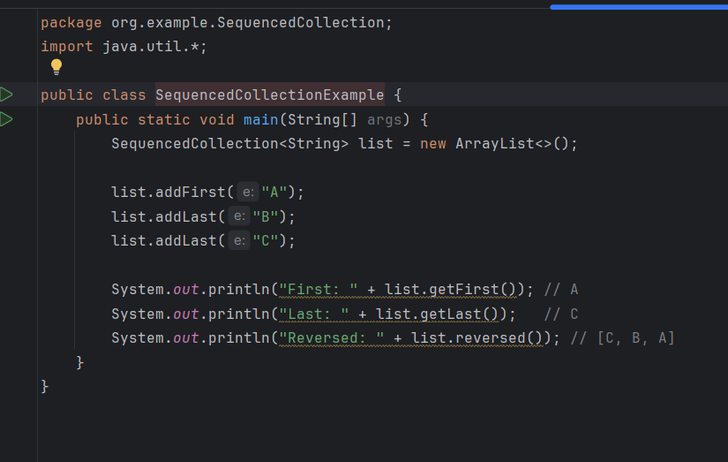Output:
First: A
Last: C
Reversed: [C, B, A]
Example with SequencedSet
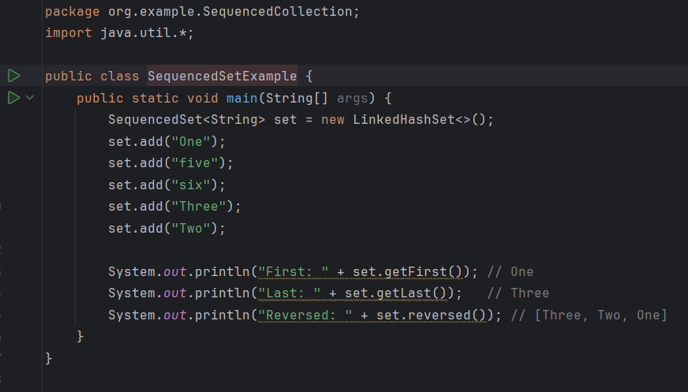
Output:
First: One
Last: Two
Reversed: [Two, Three, six, five, One]
SequencedMap
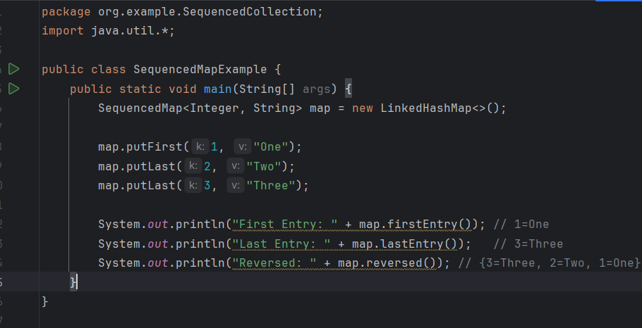Output:
First Entry: 1=One
Last Entry: 3=Three
Reversed: {3=Three, 2=Two, 1=One}

Record Patterns

Java already has records (since Java 16) → immutable data carriers.
Record Patterns allow you to deconstruct records directly in if or switch, instead of manually calling getters.
What are Record Patterns?
Record Patterns extend Java’s pattern matching by letting you deconstruct record objects directly in pattern matching constructs (like switch, instanceof, etc.).
Before: you had to extract fields manually using getters.
Now: you can destructure records inline to directly access their components.
Without record patterns:
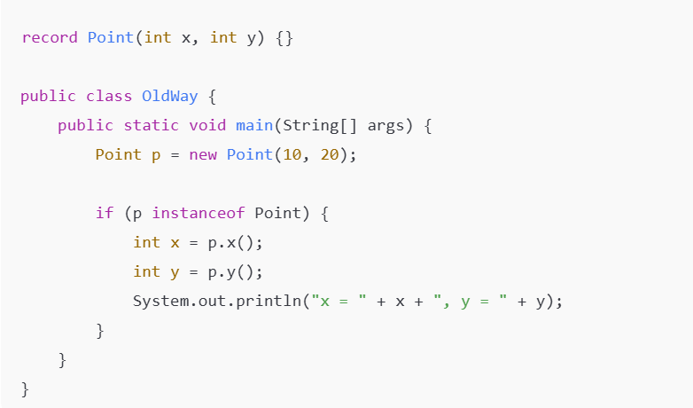

record patterns:

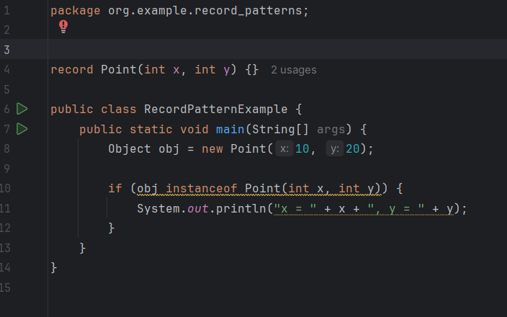

Out put:
x = 10, y = 20

Record Patterns in switch
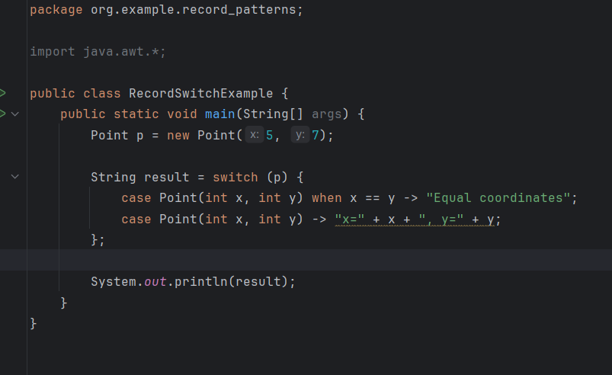
Out put:
x=5, y=7
NestedRecordExample:

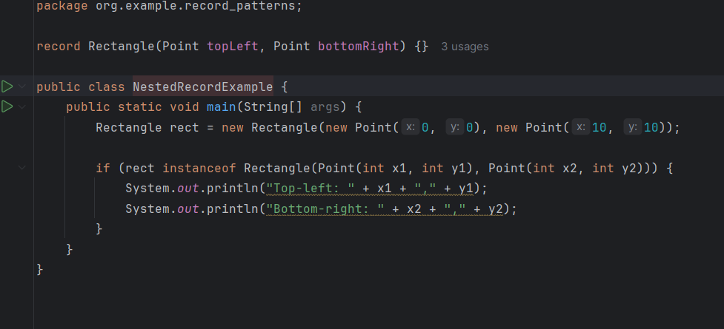
Out put:
Top-left: 0,0
Bottom-right: 10,10
instanceof in Java
Definition
- instanceof is a keyword (operator) in Java.
- It is used to check whether an object belongs to a specific class or interface.
- It returns true or false.
Pattern Matching for Switch
Pattern Matching for switch extends the switch statement (and expression) so that you can match not just constant values, but also types and conditions.
It makes switch more powerful, concise, and type-safe.
Traditionally, switch only worked with:
- primitive types (int, char, etc.)
- String
- enum constants
But with pattern matching, now switch can handle objects, types, null checks, and conditions directly.

Example 1: Basic Type Matching

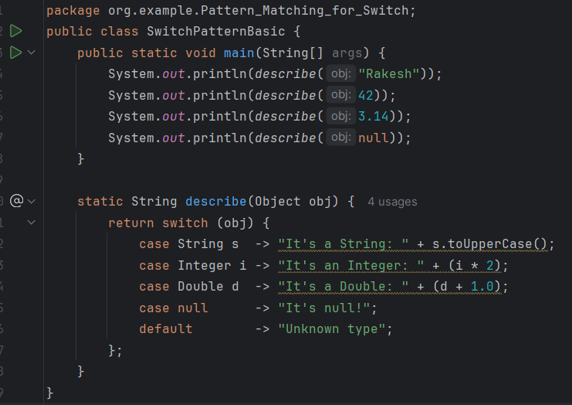
Out put:
It's a String: RAKESH
It's an Integer: 84
It's a Double: 4.140000000000001
It's null!
Explanation:
- case String s → if object is a String, assign it to variable s.
- case Integer i → matches an Integer.
- case Double d → matches a Double.
- case null → handles null safely (new in Java 21).
- default → fallback.

Example 2: Using when
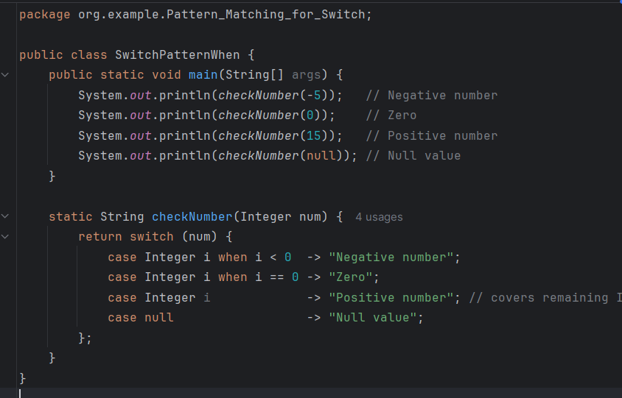

Out put:
Negative number
Zero
Positive number
Null value

Explanation:
- when adds extra conditions after the type match.
- Helps refine matching logic (like filtering negative, zero, positive).

With Record Patterns
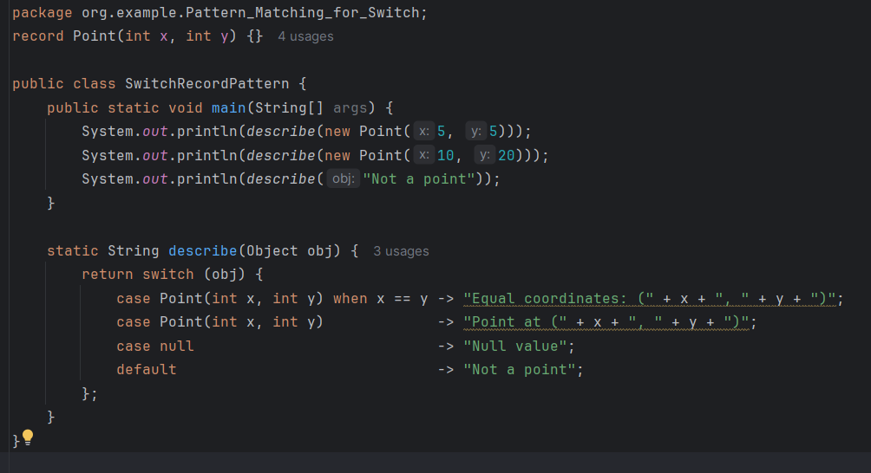
Out put:
Equal coordinates: (5, 5)
Point at (10, 20)
Not a point
Explanation:
- case Point(int x, int y) → record pattern, extracts fields directly.
- when x == y → adds condition that both coordinates must be equal.
- If not equal, falls to next case.

Combining Multiple Patterns
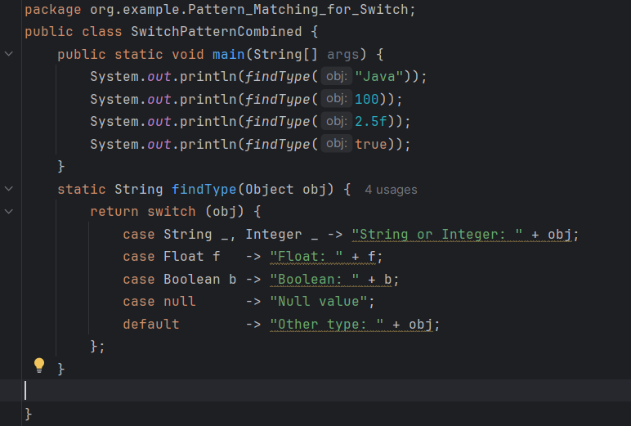
Oup put:
String or Integer: Java
String or Integer: 100
Float: 2.5
Boolean: true
Explanation:
- You can group cases with comma separated patterns (e.g., String s, Integer i).
- Covers multiple types with same logic.

Virtual Threads
Virtual Threads are lightweight threads provided by the JVM.
They are part of Project Loom, introduced in Java 19 (as preview), and standardized
in Java 21.
Unlike platform threads (which map 1:1 with OS threads), virtual threads are managed by the JVM and can number in the millions.
Before Java 21:
- Platform threads were expensive. Each required a heavy OS thread.
- If a thread was blocked on I/O (e.g., waiting for a database or network response), the OS thread was wasted.
After Java 21:
- With virtual threads, you can just write blocking code naturally, and the JVM handles the scalability.
- Millions of concurrent virtual threads are possible on modest hardware.
Example 1: Basic Virtual Thread
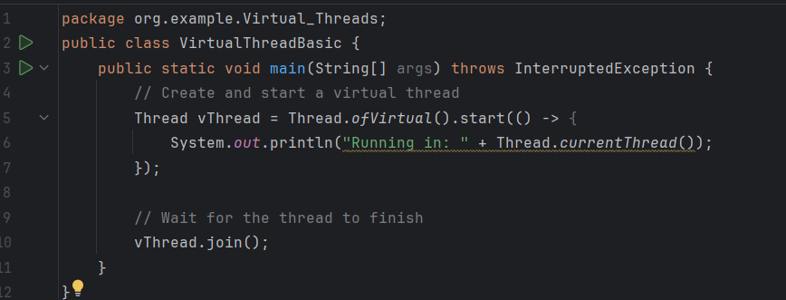
Out put:
Running in: VirtualThread[#22]/runnable@ForkJoinPool-1-worker-1
Explanation:
- Thread.ofVirtual() → creates a new virtual thread.
- .start(...) → starts execution immediately.
- Virtual threads look like normal threads, but are lighter.
- join() makes the main thread wait until the virtual thread finishes.
Example 2: Many Virtual Threads
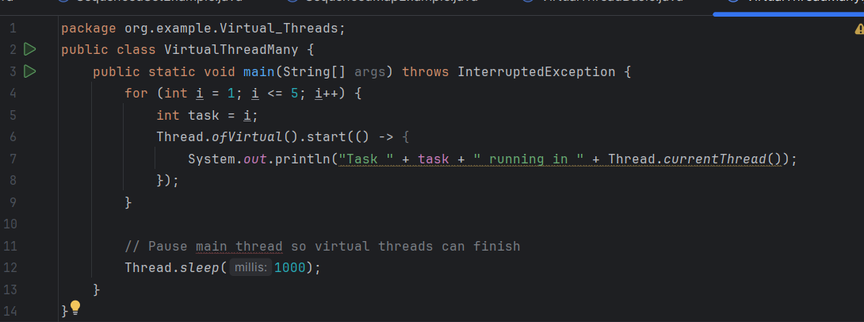

Out put:
Task 4 running in VirtualThread[#26]/runnable@ForkJoinPool-1-worker-4
Task 5 running in VirtualThread[#27]/runnable@ForkJoinPool-1-worker-5
Task 3 running in VirtualThread[#25]/runnable@ForkJoinPool-1-worker-3
Task 2 running in VirtualThread[#24]/runnable@ForkJoinPool-1-worker-2
Task 1 running in VirtualThread[#22]/runnable@ForkJoinPool-1-worker-1

Explanation:
- Creates 5 separate virtual threads.
- Each one runs independently and prints its task number.
- Unlike platform threads (OS-backed), you could scale this up to thousands or millions.

Example 3: Virtual Thread Executor
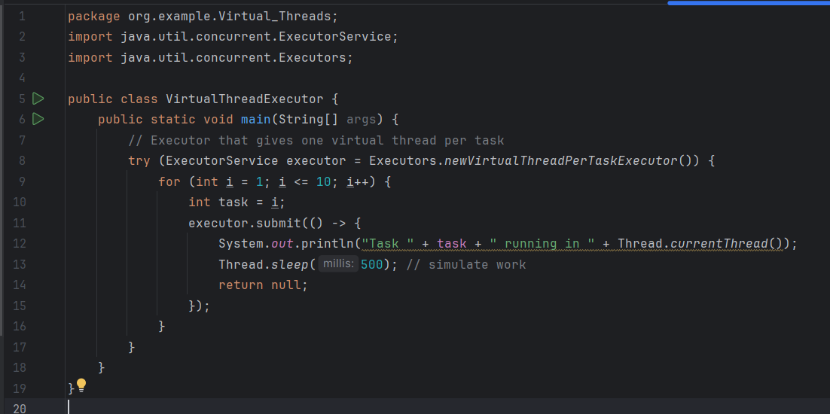
Out put:
Task 6 running in VirtualThread[#28]/runnable@ForkJoinPool-1-worker-6
Task 1 running in VirtualThread[#22]/runnable@ForkJoinPool-1-worker-1
Task 10 running in VirtualThread[#32]/runnable@ForkJoinPool-1-worker-5
Task 3 running in VirtualThread[#25]/runnable@ForkJoinPool-1-worker-3
Task 4 running in VirtualThread[#26]/runnable@ForkJoinPool-1-worker-4
Task 9 running in VirtualThread[#31]/runnable@ForkJoinPool-1-worker-2
Task 5 running in VirtualThread[#27]/runnable@ForkJoinPool-1-worker-5
Task 2 running in VirtualThread[#24]/runnable@ForkJoinPool-1-worker-2
Task 7 running in VirtualThread[#29]/runnable@ForkJoinPool-1-worker-7
Task 8 running in VirtualThread[#30]/runnable@ForkJoinPool-1-worker-8
Explanation:
- Executors.newVirtualThreadPerTaskExecutor() → every submitted task runs in its own virtual thread.
- Unlike traditional executors (newFixedThreadPool), no need to carefully size the pool.
- Virtual threads are so cheap that one per task is efficient.
- try-with-resources ensures the executor closes after all tasks complete.

Example 4: Blocking I/O with Virtual Threads
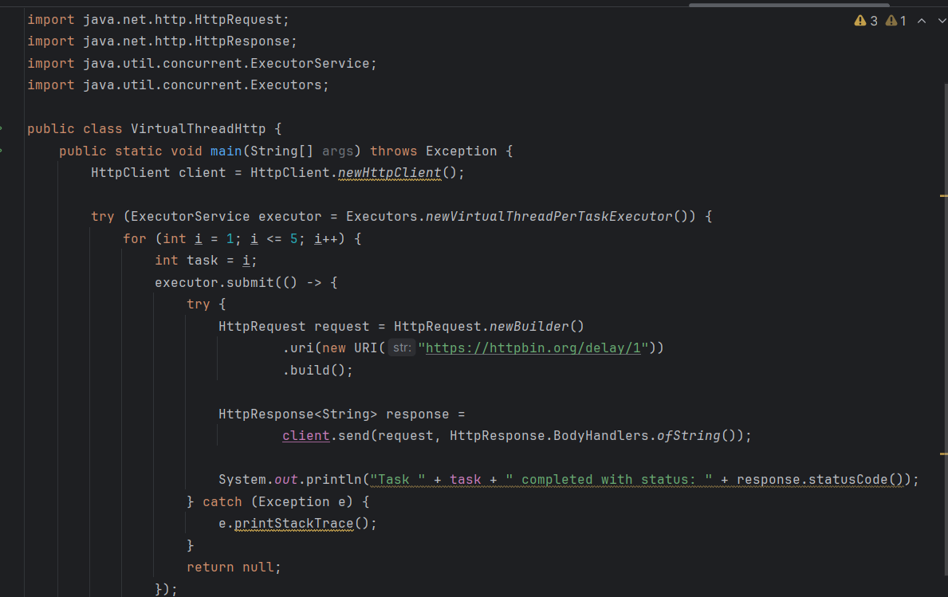
Out put:
Task 2 completed with status: 200
Task 1 completed with status: 200
Task 5 completed with status: 200
Task 4 completed with status: 200
Task 3 completed with status: 200
Explanation:
- Each task makes an HTTP request to a slow endpoint (/delay/1).
- Traditionally, blocking I/O would “waste” a thread.
- With virtual threads, the JVM parks (pauses) them → freeing OS resources until data arrives.
- This allows massive scalability without async complexity (Completabl eFuture, callbacks, etc.).

